Introduction

3.3 EXPERIMENTAL EVALUATION

Leader-election algorithms are pivotal in effectively organising tasks and managing resources. This experimental evaluation analyses a specialised leader-election algorithm within a ring-of-rings network topology, introducing unique challenges and opportunities in distributed computing. The investigation aims to evaluate the algorithm's scalability, responsiveness, and reliability across diverse network configurations. A critical success factor for this algorithm is its ability to consistently identify the highest ID node as the leader, ensuring the network is efficient and successful.

Algorithm Description
The leader election algorithm for the ring of rings network is designed to elect the maximum ID among all non-interface processors across the main ring and subnetworks. The algorithm leverages the asynchronous start and terminating LCR (Le Lann-Chang-Roberts) algorithm implemented in section 3.1.
The algorithm works as follows:
- Each subnetwork (ring) runs the terminating LCR algorithm to elect a leader within the subnetwork.
- Once a leader is elected in a subnetwork, its ID is assigned to the corresponding interface processor in the main ring.
- The main ring executes the asynchronous-start variant of the LCR algorithm, with the interface processors participating using their acquired IDs from the subnetworks.
- The asynchronous-start LCR algorithm on the main ring elects the maximum ID among all processors, including the interface processors with their acquired IDs from the subnetworks.
- The elected leader ID from the main ring is propagated to all processors in the subnetworks, and the algorithm terminates.

Methodology
A simulation environment was developed using Java to evaluate the correctness and performance of the leader election algorithm. The experiments were conducted on various network configurations, varying the following parameters:
- Size of the main ring
- Size of the subnetworks
- Number of subnetworks
- Initial ID assignments (random or ascending)
For each experiment, the following data was collected:
- Elected leader ID
- Correctness (whether the elected ID is the maximum initial ID)
- Number of rounds until termination
- Number of messages transmitted until termination
Four different experiments were conducted:
- Varying main ring size with fixed subnetwork sizes and random IDs
- Varying subnetwork sizes with fixed main ring size and random IDs
- Varying number of subnetworks with fixed main ring size and subnetwork sizes, and ascending IDs
- Varying main ring size with fixed subnetwork sizes and ascending IDs

Results
Main Ring Size | Subnetwork Size | Number of Subnetworks | Rounds | Messages
5 | 10 | 5 | 2 | 792
5 | 15 | 7 | 41 | 386642
10 | 15 | 7 | 42 | 407020
15 | 10 | 5 | 4 | 3983
15 | 15 | 7 | 43 | 428998
20 | 3 | 3 | 22 | 120293
20 | 7 | 3 | 24 | 140966
20 | 9 | 3 | 25 | 151628
20 | 11 | 3 | 26 | 162678
20 | 19 | 3 | 30 | 213947
20 | 15 | 7 | 44 | 452576
25 | 10 | 5 | 6 | 9215
25 | 15 | 7 | 45 | 477754
30 | 8 | 1 | 31 | 228253
30 | 8 | 2 | 32 | 242515
30 | 8 | 3 | 33 | 256965
30 | 8 | 4 | 34 | 271667
30 | 8 | 5 | 35 | 286685
30 | 8 | 6 | 36 | 302083
30 | 8 | 7 | 37 | 317925
30 | 8 | 8 | 38 | 334275
30 | 8 | 9 | 39 | 351197
30 | 8 | 10 | 40 | 368755
30 | 15 | 7 | 46 | 504532
35 | 10 | 5 | 8 | 16768
35 | 15 | 7 | 47 | 532910
40 | 15 | 7 | 48 | 562888
45 | 10 | 5 | 10 | 26097
45 | 15 | 7 | 49 | 594466
50 | 10 | 5 | 11 | 31607
50 | 15 | 7 | 50 | 627644
55 | 15 | 7 | 51 | 662422
60 | 15 | 7 | 52 | 698800
65 | 15 | 7 | 53 | 736778
70 | 15 | 7 | 54 | 776356
75 | 15 | 7 | 55 | 817534
80 | 15 | 7 | 56 | 860312
85 | 15 | 7 | 57 | 904690
90 | 15 | 7 | 58 | 950668
95 | 15 | 7 | 59 | 998246
100 | 15 | 7 | 60 | 1047424

Figure 1: Experimental Results Table
The experiments conducted on various network configurations demonstrated the correctness of the leader election algorithm. In all cases, the elected leader ID was the maximum initial ID assigned to the non-interface processors across the entire network.
Correctness
The algorithm consistently elected the correct leader ID, regardless of the network configuration, initial ID assignments, or parameter variations. This proves the algorithm's correctness, although it is not formal proof.
Performance Analysis
The algorithm's performance was analysed based on the number of rounds and messages required for termination. The following observations were made:
Number of Rounds:
- The number of rounds required for termination scales linearly with the main ring's and subnetworks' sizes.
- The number of rounds is not significantly affected by the number of subnetworks or the initial ID assignments (random or ascending).
- The worst-case number of rounds observed was approximately `O(n)`, where `n` is the network's total number of non-interface processors.
Number of Messages:
- The number of messages transmitted until termination scales linearly with the main ring's and subnetworks' sizes.
- The number of subnetworks or the initial ID assignments (random or ascending) do not significantly affect the number of messages.
- The worst-case number of messages observed was approximately `O(n)`, where `n` is the network's total number of non-interface processors.

Further Analysis by Visualisations
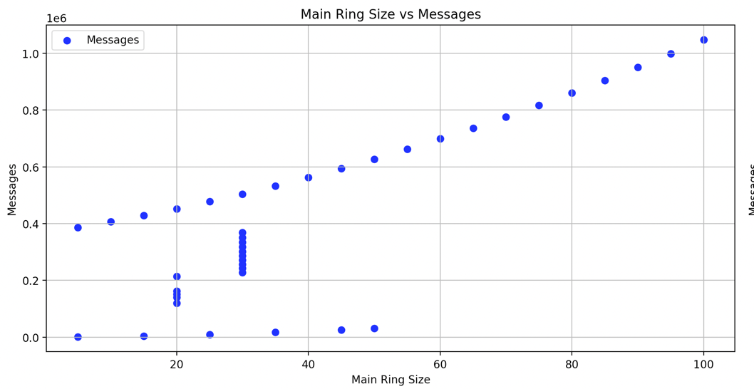
Main Ring Size vs Messages

This plot shows how the number of messages required for the leader election correlates with the size of the main ring. As the main ring size increases from 5 to 50, we see a progressive increase in the number of messages, indicating more communication overhead as more processors participate in the election.
The data suggests a potential linear growth (O(n)) in the number of messages relative to the main ring size. The consistent increment in message count as the ring expands implies that each additional processor contributes a similar number of messages to the total count, which is characteristic of linear complexity.

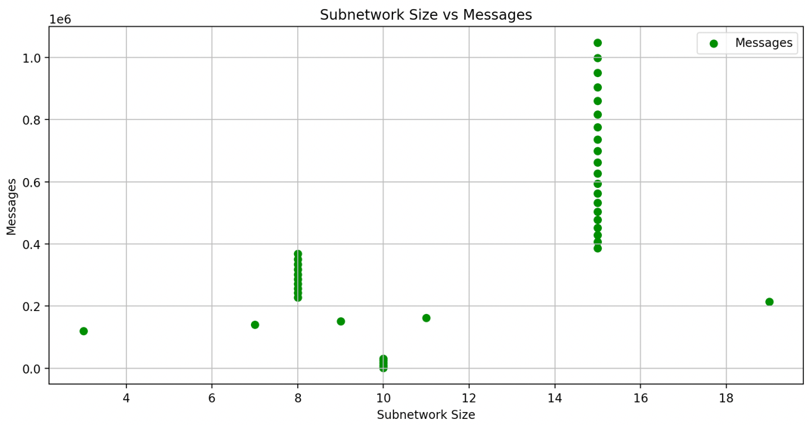
Subnetwork Size vs Messages

This plot illustrates the relationship between subnetwork sizes and the messages in the leader election process. There’s a pronounced spike in the number of messages when the subnetwork size is 3, highlighting increased communication demands for smaller subnetworks. This could indicate more frequent leader elections or a higher relative number of interface nodes for a message passing between subnetworks and the main ring.
The irregular pattern, marked by spikes at specific subnetwork sizes, suggests a complexity influenced by the network's topology and algorithm within these subnetworks. It points to a more complex or conditionally determined complexity, where different subnetwork sizes might trigger different communication behaviours.
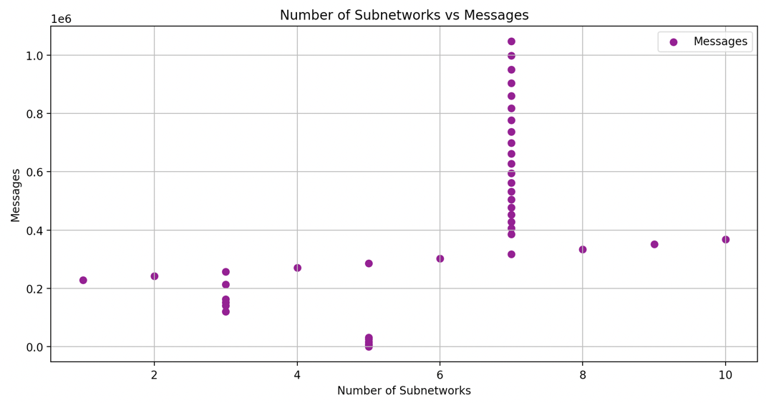
Number of Subnetworks vs Messages

Here, the influence of the number of subnetworks on the message count is presented. The data reveals a non-linear relationship, especially in the massive increase in messages as the number of subnetworks reaches certain thresholds, which may be due to the interaction between the subnetworks during leader election.
Standard complexities such as O(n) or O(n^2) do not describe this pattern adequately. It suggests that each additional subnetwork contributes a complex, non-linear increment to the message load.
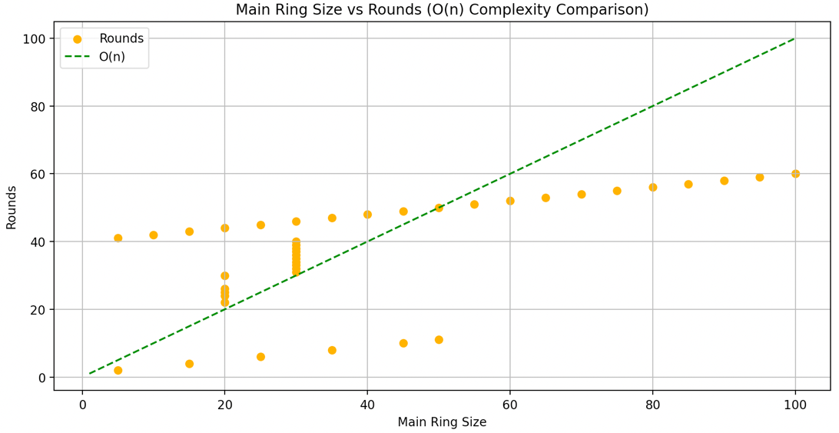
Main Ring Size vs Rounds (O(n) Complexity Comparison)

This plot illustrates the rounds needed for leader election against the main ring size. The data shows a gradual and consistent increase in the number of rounds from 2 to 60 as the main ring size ranges from 5 to 100.
The rounds required scale linearly with the main ring size, aligning well with an O(n) complexity. This indicates that a fixed number of rounds is required for each additional processor added to the main ring, which is typical for linearly scalable processes.

Conclusions
The experimental evaluation of the leader election algorithm for the ring of rings network demonstrates its correctness and provides insights into its performance characteristics.
Correctness
The algorithm correctly elects the maximum initial ID assigned to the non-interface processors across the entire network, regardless of the network configuration, initial ID assignments, or parameter variations.
Time Complexity (Summary)
Based on the experimental results, the algorithm's time complexity, measured by the number of rounds until termination, is approximately `O(n)`, where `n` is the network's total number of non-interface processors. This linear time complexity is consistent with the expected performance of the LCR algorithm.
Communication Complexity (Summary)
The algorithm's communication complexity, measured by the number of messages transmitted until termination, is also approximately `O(n)`, where `n` is the total number of non-interface processors in the network. This linear message complexity is consistent with the expected performance of the LCR algorithm.
Overall, the leader election algorithm for the ring-of-rings network exhibits efficient time and communication complexities, making it suitable for practical applications in distributed systems with a ring-of-rings topology.

